How to Create an Amazon S3 Bucket in AWS
Article ID: KB-AWS-S3-001 Category: Cloud Storage | AWS Last Updated: April 2026 Audience: Developers, Cloud Administrators, DevOps Engineers

Overview
Amazon Simple Storage Service (Amazon S3) is an object storage service offering industry-leading scalability, data availability, security, and performance. This article walks you through the prerequisites and step-by-step process of creating an S3 bucket via the AWS Management Console.

Prerequisites
Before creating an S3 bucket, ensure the following are in place:
1. AWS Account
- You must have an active AWS account. If you don't have one, sign up at https://aws.amazon.com.
- A valid credit/debit card is required during sign-up (used only if you exceed the Free Tier limits).
2. IAM User / Role with Required Permissions
- Avoid using the root account for day-to-day operations.
- Create or use an IAM User with the following minimum permissions:
Permission | Purpose
s3:CreateBucket | Allows bucket creation
s3:PutBucketPolicy | Allows attaching bucket policies
s3:ListAllMyBuckets | Allows viewing existing buckets
s3:GetBucketLocation | Allows checking bucket region
💡 Tip: For full access during initial setup, you may attach the AWS managed policy AmazonS3FullAccess to your IAM user.

3. Step-by-Step Procedure
Step 1: Log in to AWS Management Console
- Login to the AWS management console. This link is given. https://aws.amazon.com/console/ , either you can use the IAM user access or you can use the root user email and password. Authenticate it if you have enabled any MFA. refer Image1
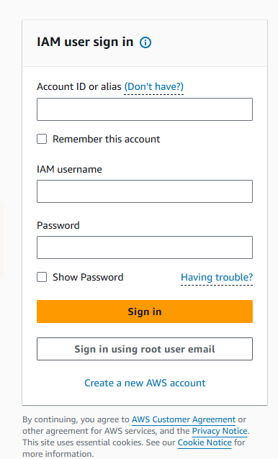
Image1
Tip: Always choose the region closest to your users for lower latency.
Step 2: Navigate to S3 Dashboard
In the search bar at the top, type "S3", it will populate all the S3 related options. Click on S3 under Services.

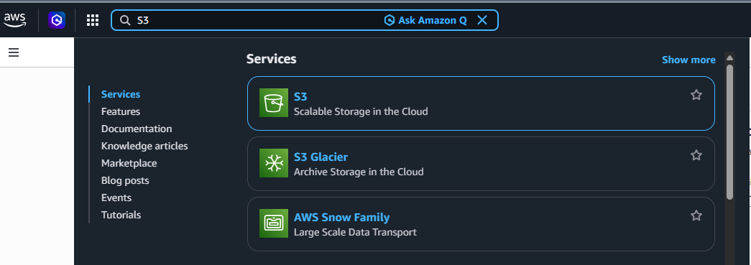

Step 3 — Click "Create Bucket"
Once clicked on S3, the S3 dashboard page will open. In this page click on Create bucket to create a new bucket.
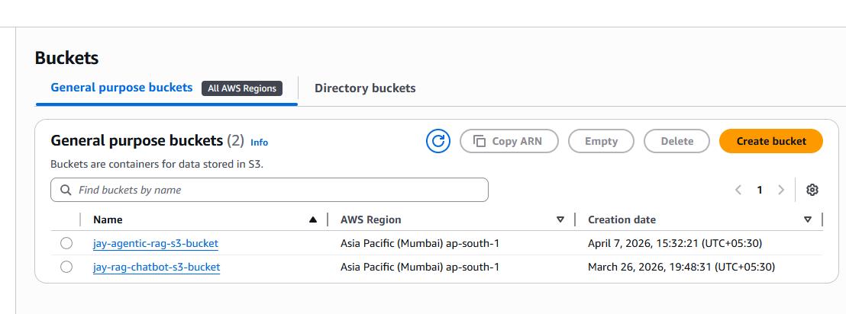
Step 4 — Configure General Settings
Once “create bucket” is clicked, a new page opens for bucket creation. Provide the general settings here. Select the bucket type as per requirement. Provide the bucket name. Below details may help.
Fill in the following fields:
Field | Description | Example
Bucket name | Globally unique name | my-company-data-bucket-2026
AWS Region | Region to host the bucket | ap-south-1 (Mumbai)
Copy settings (optional) | Copy config from an existing bucket | Leave blank for new setup

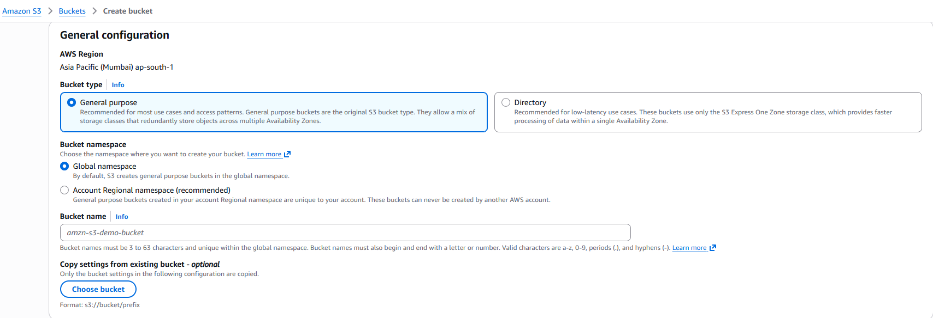
Step 5 — Object Ownership
Choose how object ownership is managed:
ACLs disabled (Recommended): Bucket owner automatically owns all objects. Best practice for most use cases.
ACLs enabled: Allows use of Access Control Lists for fine-grained object-level permissions.
✅ Best Practice: Select "ACLs disabled" unless you have a specific need for ACLs.
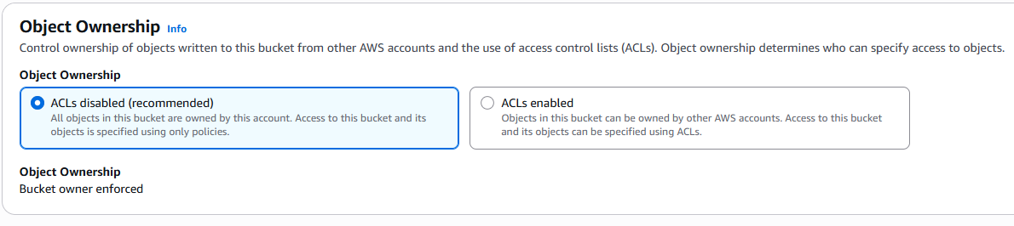
Step 6 — Block Public Access Settings
By default, AWS blocks all public access. Unless you're hosting a public static website, keep all four options checked (enabled).
☑ Block all public access
☑ Block public access to buckets and objects granted through new ACLs
☑ Block public access to buckets and objects granted through any ACLs
☑ Block public access to buckets and objects granted through new public bucket or access point policies

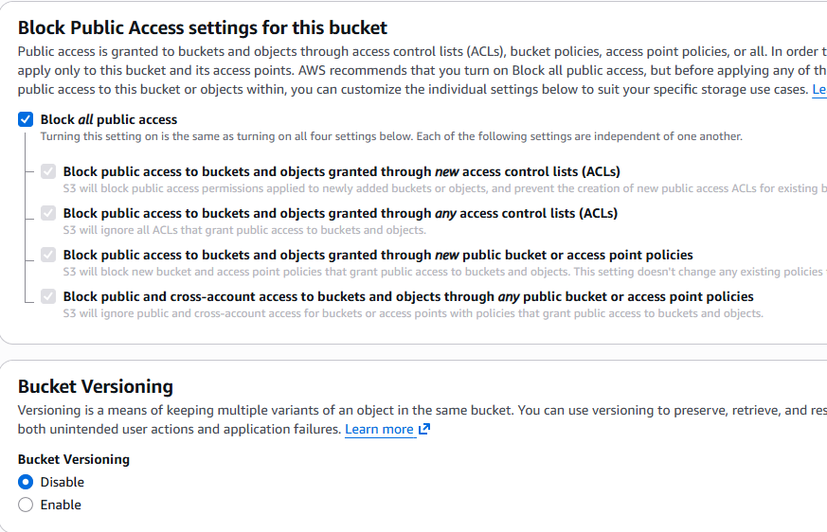

Step 8 — Tags (Optional)
Add tags for cost tracking, resource management, or automation:
Key | Value
Environment | Production
Team | DevOps
Project | DataPipeline

Step 9 — Default Encryption
AWS S3 now enforces server-side encryption by default. Choose an encryption type:
Option | Description
SSE-S3 | AWS-managed keys (default, simplest)
SSE-KMS | AWS Key Management Service keys (more control)
DSSE-KMS | Dual-layer encryption using KMS
💡 For most use cases, SSE-S3 is sufficient and requires no additional cost.
Once all details are entered, click on Create bucket. This will create the S3 bucket.

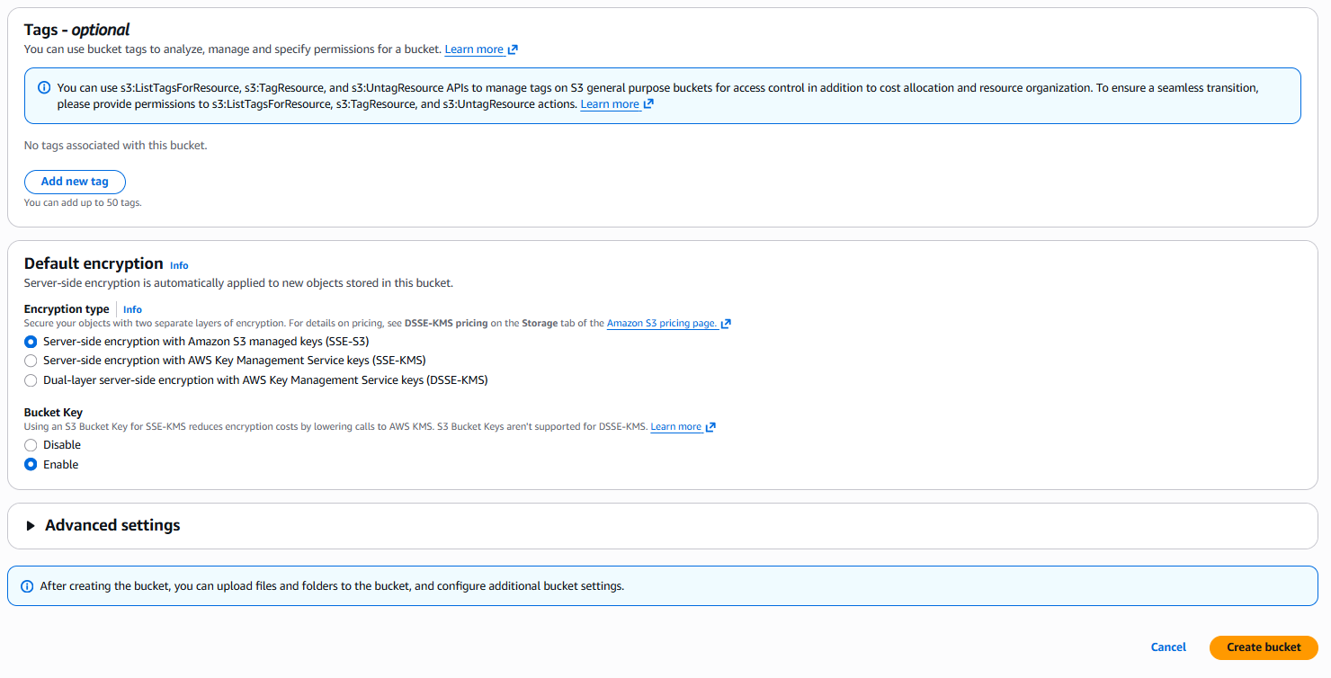
Step 10 — S3 bucket Created
Now finally, open the S3 dashboard again, it will display all the S3 buckets created.

